|  |  |  |  |
| --- | --- | --- | --- |
| **Group No.** | **Group Members** | | |
|  | **ID** | **Name** |
| **3** | 1. | **20-42195-1** | **LEO, NAFINUR** |
| 2. | **20-42752-1** | **HOWLADER, MD. SHAKIB** |
| 3. | **20-42794-1** | **FAHIM, SHAH NAWAJ** |
| 4. | **20-42853-1** | **RAHMAN, HASIBUR** |
| 5. | **20-42870-1** | **HASSAN, MD. ALIF** |
|  |  |  |

**Laboratory Experiment Report**

Electronic Devices Laboratory

Semester: Spring 2021-22

|  |  |  |
| --- | --- | --- |
| **Experiment No.:** 9 |  | |
| **Experiment Title:** Study of MOSFET Common Source (CS) Small Signal Amplifier. . |  | |
| **Date of Experiment: 03-04-2022** | | **Date of Report Submission: 17-04-2022** |

**Marking Rubrics for Laboratory Report (to be filled by Faculty)**

|  |  |  |  |  |
| --- | --- | --- | --- | --- |
| **Objectives** | **Unsatisfactory (1)** | **Good (2-3)** | **Excellent (4-5)** | **Marks** |
| **Theory** | The relevant theories are not being described properly. | Part of the relevant theories are described with proper mathematical expression and circuit diagrams (if any) | All the relevant theories are included with proper descriptions, mathematical expressions and circuit diagrams. (if any) |  |
| **Simulation circuits & Results** | Simulation circuits are not included in this report. | Partial simulation circuit results are included in this report. | All the simulation circuits are included in this report with appropriate results. |  |
| **Report Question, Discussion on Comparison between theoretical and simulation results** | Cannot reach meaningful conclusions from experimental data; Cannot summarize or compare findings to expected results | Can extract most of the accurate data. Answers to the report questions are partially correct; Summarize finding in an incomplete way | Can extract all relevant conclusion with appropriate answer to the report questions; Summarize finding in a complete & specific way |  |
| **Organization of the report** | Report is not prepared as per the instruction. | Report is organized despite of few missing sections as per the recommended structure. | Report is very well organized. |  |
| **Comments** | Assessed by (Name, Sign, and Date) | | Total (out of 20): |  |

**Experiment title:** Study of MOSFET Common Source (CS) Small Signal Amplifier.

Objective of this experiment:

The objective of this experiment are,

* to become familiar and study the characteristics of MOSFET common source (CS) amplifier.
* to determine the voltage gain, input and output voltages by using DC and AC analysis.
* to investigate the input and output waveforms of CS amplifier circuit.

**Theory:**

The MOSFET structure has become the most important device structure in the electronics industry. It dominates the integrated circuit technology in Very Large Scale Integrated (VLSI) digital circuits based on n-channel MOSFETs and Complementary n-channel and p-channel MOSFETs (CMOS). The technical importance of the MOSFET results from its low power consumption, simple geometry, and small size, resulting in very high packing densities and compatibility with VLSI manufacturing technology.

Two of the most popular configurations of small-signal MOSFET amplifiers are the common source and common drain configurations. The common source circuit is shown in Figure 1. The common sources, like all MOSFET amplifiers, have the characteristic of high input impedance. High input impedance is Experiment 09: Lab manual © Dept. of EEE, Faculty of Engineering, American International University-Bangladesh (AIUB) 2 desirable to keep the amplifier from loading the signal source. This high input impedance is controlled by the bias resistor RG (or bias resistors RG1 and RG2). Normally the value of the bias resistor(s) is chosen as high as possible. However too big a value can cause a significant voltage drop due to the gate leakage current. A large voltage drop is undesirable because it can disturb the bias point. For amplifier operation the MOSFET should be biased in the saturated region of the characteristics.

The common source (CS) and common drain (CD) MOSFET amplifiers can be compared to the common emitter (CE) and common collector (CC) BJT amplifiers respectively. Like the CE amplifier, the CS amplifier has a negative voltage gain and an output impedance approximately equal to the drain resistor (collector resistor for the CE amplifier). The CD amplifier is comparable to the CC amplifier with the characteristics of high input impedance, low output impedance, and less than unity voltage gain.

**Apparatus:**

1. Resistors: 5.6 kΩ, 10 kΩ, 100 kΩ, 1MΩ.
2. MOSFET: n-channel MOSFET (IRF540 or similar).
3. Capacitor: 22 μF (2).
4. Connecting wires.
5. Trainer Board.
6. Multimeter.
7. DC power supply.
8. Power cables and probes.
9. Oscilloscope.
10. Function generator.

**Simulation circuits and Results:**

**R**

**D**

**5**

**.**

**6**

**k**

**Ω**

**1**

**.**

**0**

**M**

**Ω**

**R**

**G**

**R**

**L**

**10**

**k**

**Ω**

**C**

**1**

**22**

**µF**

**V**

**in**

**V**

**DD**

**10**

**V**

**C**

**2**

**22**

**µF**

**V**

**0**

**20**

**mV**

**10**

**kHz**

**G**

**S**

**D**

**Figure 1: MOSFET Common Source Amplifier**

**Experimental Procedure:**

1. Construct the circuit as shown in Figure 1.

2. DC Analysis: Connect the MOSFET CS amplifier circuit shown in Figure 1. Use a Multimeter to measure the transistor voltages (VD, VG, VS) and drain current (ID). Compare all DC results to your prelab calculations.

3. AC Analysis: Apply a sine wave (20mV, 10 kHz). Display both input and output signals on the oscilloscope and observe the phase shift. Measure the output voltage and compute the voltage gain.

4. Finally, increase the input amplitude until you observe clipping in the output. Plot and label the clipped output. What is the maximum input that can be amplified without distortion (clipping)?

**Data Tables:**

**Table -1 (DC Analysis)**

|  |  |  |  |  |  |  |  |  |
| --- | --- | --- | --- | --- | --- | --- | --- | --- |
| **VCC** |  |  | **VD** |  | **VS** |  | **VG** | **ID** |
| 10 V |  |  |  | 3.1 V | 0.1 V | 3.11 | V | 1.2 mA |

**Table -2 (AC Analysis)**

|  |  |  |  |  |  |  |  |
| --- | --- | --- | --- | --- | --- | --- | --- |
| **Frequency** |  | **Vin** |  | **Max. Vin** | **V0** | **AV** | **Phase Difference** |
| 10 KHz | 200 mV | | | 100 mV | 6.4 V | 32 mV | 0 |

**Simulation and Measurement:**

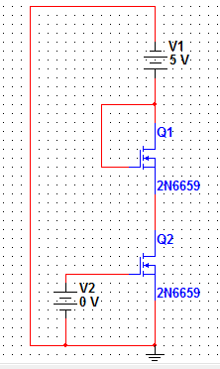

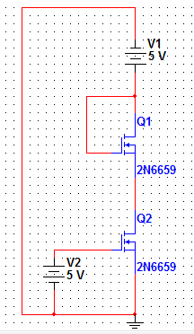

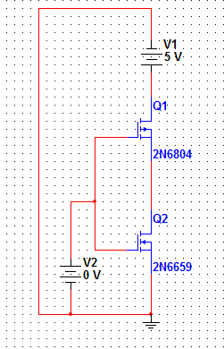

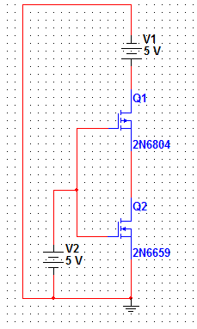

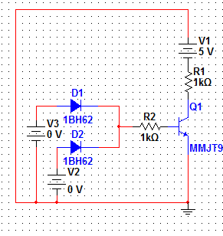

**Discussion:**

All the apparatus were checked before the start of the experiment. The oscilloscope was  
calibrated before the start of the experiment. Care should be taken to avoid short connections.  
Short connections can produce heat (due to high current flow) which can be harmful for the  
components and damage the component. This experiment was performed to study about the switching characteristics and switching loss of MOSFET. The data and the ploted curves obtained from the experiment proved that MOSFET does not activate until a certain gate voltage is provided and the power loss increases after  
crossing the gate voltage.

**References:**

1. American International University–Bangladesh (AIUB) Electronic Devices Lab Manual.

2. A.S. Sedra, K.C. Smith, Microelectronic Circuits, Oxford University Press (1998).

3. J. Keown, ORCAD PSpice and Circuit Analysis, Prentice Hall Press (2001).

4. P. Horowitz, W. Hill, The Art of Electronics, Cambridge University Press (1989).